

press release
(English translation)

FASHION AND THE TEXTILE INDUSTRY: TARGET SUSTAINABILITY.
FROM ECOMONDO, THE REAL CHALLENGE FOR THE SECTOR’S FUTURE

At the round table on fashion, convened for 6 August by Adolfo Urso, Minister of Enterprise and Made in Italy, the IEG event will stress the importance of the sector’s sustainable transition through the Textile District, a themed area dedicated to sustainability in the fashion world, and a series of landmark events regarding textile waste hosted at Rimini Expo Centre from 5th to 8th November
Rimini, 5th August 2024 - With a turnover of more than 102 billion euros in 2023, around 60,000 companies, 600,000 employees and a 4% share of the national GDP, 90% of which is generated by exports, the fashion industry is Italy's third largest manufacturing sector. However, the textile industry is also among those with the greatest ecological impact: globally, it is the second most polluting industry after oil, consuming 93 billion cubic metres of water every year, and is responsible for 20% of the pollution of the Earth's drinking water and 10% of CO² emissions.
At the round table on fashion, convened for Tuesday 6th August by the Minister of Enterprise and Made in Italy, Adolfo Urso, to discuss the crisis in the textile sector and possible solutions, Ecomondo - the leading event in the Mediterranean basin for the green and circular economy sector, to be held at Rimini Expo Centrer from 5th to 8th November next and organised by Italian Exhibition Group (IEG) - is offering itself as a discussion hub to address issues related to the environmental challenges that the textile industry is facing.
One of the most critical issues in the sector is, in fact, the end-of-life management of clothes and non-reusable textile fibres. Globally, less than 1% of textile waste is recycled. Much of this waste is exported and ends up in large landfills in Asia, Africa and South America.
In Italy, according to Ispra data, 160,000 tonnes of textile waste were produced in 2022 with an average of about 2.7 kg per inhabitant, of which only 22% is collected for reuse or recycling.
The European Union's introduction of the Extended Producer Responsibility Schemes (EPR) for textile products, which will oblige producers to cover the costs of textile waste management, and the obligation of separate collection for textile products as of 2025, need to be accompanied by regulatory, infrastructural and technological solutions for the sector’s transition towards a circular and sustainable production model.
A possible incentive for the sector’s circularity could come from the introduction of minimum recycled fibre regimes in all new products, a possible derogation from the REACH directive (Registration, Evaluation, Authorisation and Restriction of Chemicals) and current regulation, to make end-of-life management of these materials easier, thus avoiding waste dispersion.
Challenges and possible solutions for the textile sector will be discussed at Ecomondo 2024, which deals specifically with technologies, services and industrial solutions in the green and circular economy sectors, and where, through proposals for innovation and dialogue in the Textile District, the themed area for sustainability in the world of fashion, critical environmental issues in the textile sector will also be addressed. The topic of waste produced by the supply chain is one of the main initiatives of this edition and will be the focus of the conference “Urban textile waste: collection, reuse and recycling. At what point are we?", organised by Ecomondo’s Technical Scientific Committee and UNIRAU, where sector experts will discuss separate waste collection models, sorting and recycling technologies, eco-design, blockchains and digital passports. Particular attention will be devoted to updating the regulatory framework and the technological criticalities of textile recycling.
______________________________________
INSTITUTIONAL PARTNERS
Ecomondo 2024 is organised by Italian Exhibition Group in collaboration with: European Commission; Ministry for the Environment and Energy Security; Ministry of Enterprise and Made in Italy; ITA - Italian Trade & Investment Agency; Emilia-Romagna Region; Rimini Municipal Council; ANCI (National Association of Italian Municipalities); ANFIA (National Association of Automotive Industries); ART-ER; CIB (Italian Biogas Consortium); CIC (Italian Composters Consortium); CONAI (National Packaging Consortium); ENEA; Assoambiente; Sustainable Development Foundation; ISPRA (Institute for Environmental Protection and Research); Legambiente; UNICIRCULAR (Assoambiente section); UNACEA (National Union of Construction Equipment & Attachment Companies); UTILITALIA; CIHEAM (International Center For Advanced Mediterranean Agronomic Studies) CBE JU (Circular Bio-based Europe Joint Undertaking); EBA (European Biogas Association); European Environment Agency; ISWA (International Solid Waste Association); WBA (World Biogas Association); Water Europe.

ABOUT ECOMONDO 2024
Event: International Trade Show; Organisation: Italian Exhibition Group S.p.A.; Frequency: annual; Edition: 27th; Dates: 5-8 November; mail: ecomondo@iegexpo.it; Website: www.ecomondo.com; Facebook: www.facebook.com/EcomondoRimini; Twitter: http://twitter.com/Ecomondo; LinkedIn: https://www.linkedin.com/company/ecomondo-the-green-technologies-expo/

PRESS CONTACT IEG
Head of media relation & corporate communication: Elisabetta Vitali; press office manager: Marco Forcellini, Pierfrancesco Bellini; international press office coordinator: Silvia Giorgi; media@iegexpo.it

MEDIA AGENCY: Hill & Knowlton
Valentina Corsi, +39 327 0425730 - valentina.corsi@hillandknowlton.com
Francesca De Angelis, +39 342 7460159 - francesca.deangelis@hillandknowlton.com

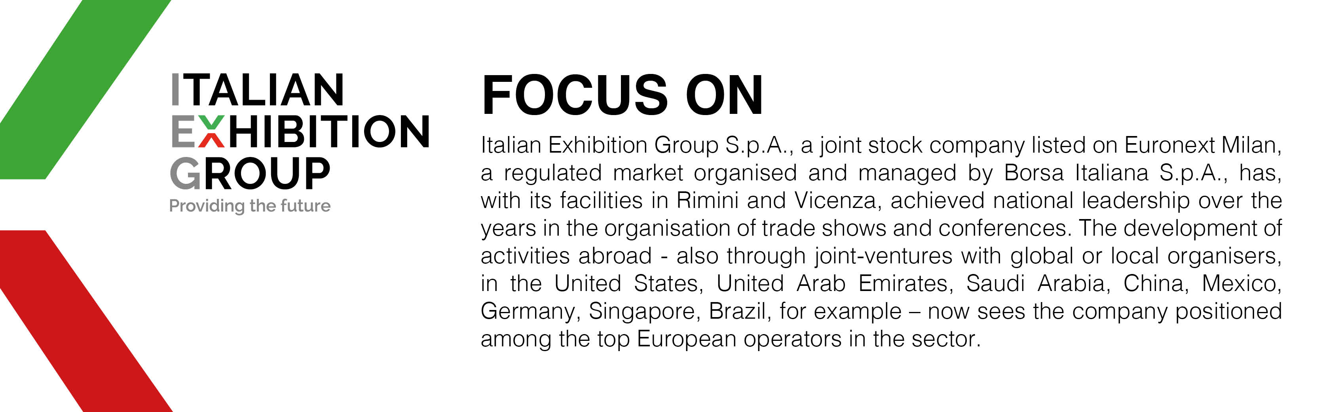

This press release contains forecast elements and estimates that reflect the management’s current opinions (“forward-looking statements”), particularly regarding future management performance, realization of investments, cash flow trends and the evolution of the financial structure. For their very nature, forward-looking statements have a component of risk and uncertainty, as they depend on the occurrence of future events. The effective results may differ (even significantly) from those announced, due to numerous factors, including, only by way of example: food service market and tourist flow trends in Italy, gold and jewellery market trends, green economy market trends; the evolution of raw material prices; general macroeconomic conditions; geopolitical factors and evolutions in the legislative framework. Moreover, the information contained in this release does not claim to be complete, and has not been verified by independent third parties. Forecasts, estimates and objectives contained herein are based on the information available to the Company as at the date of this release.

Ispra data (https://www.isprambiente.gov.it/files2023/pubblicazioni/rapporti/rapportorifiutiurbani_ed-2023_n-393_versioneintegrale.pdf)

